Project Proposal

Contents
Page 3-9
Research
Page 10-11
Business Context
Page 11
Project Aim
Page 12-18
Functional Requirements
Page 18-19
Non-Functional Requirements
Page 20
Hierarchy Diagram
Page 20-21
UI considerations
Page 21-22
Security considerations and risk mitigation
Page 23
Legal and regulatory requirements

Set Task brief:
Develop a solution for a local venue hire business, CityPoint Room Hire.
- Room hires for meetings, training sessions, and private events
- Equipment hires such as projectors, speakers, and seating
- Short-term and day-long bookings for community groups and businesses
- Provide customers info about rooms available for hire and their facilities
- Provide info about booking policies and staff details for the company
- Allow customers to book specific dates and times pending confirmation
- Allow customers to view and manage their existing bookings
- Account registration to allow customers to manage their bookings and data
- Accessibility features to support a wide range of users
- A staff area to manage rooms and booking requests that they can confirm or deny

Business context
Project aim
Functional Requirements
Non-Functional Requirements
Hierarchy Diagram
UI considerations
Security and Risk mitigation (risk matrix)
Legal and regulatory guidelines

This is a reminder for myself on the task brief and each section

Research
Example 1: Hire Space
Link: https://hirespace.com/
The first impression from this venue hire business is that it asks the customer to find their venue. Getting straight to the point, the UI is quite simple too, where anyone who is or isn’t technologically inclined can navigate and figure out how to search for a venue.
The design of the website is also quite simple itself with a minimalism approach. This is because typically people who hire venues are on the older side who are looking to get married, celebrate birthdays, photoshoots, etc. Therefore, it appeals to the older audience.

Another thing to notice is that it shows statistics on how many events, venues and clients they have found. This brings up trust to any user or customer viewing the website because the large number means many of the venues people hired out went well.
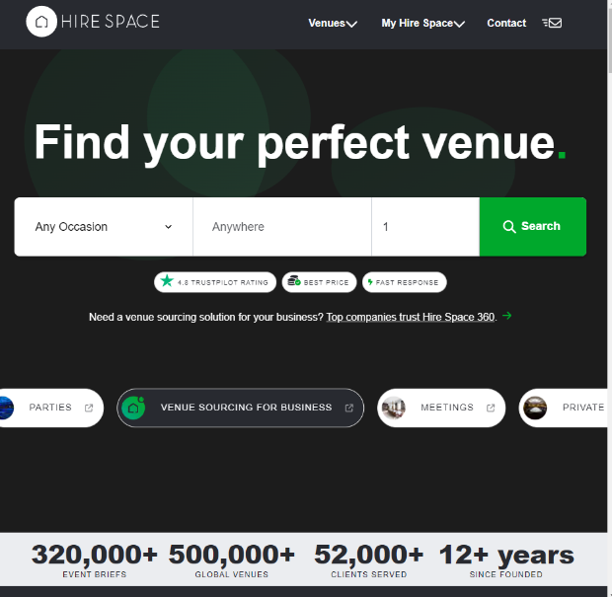

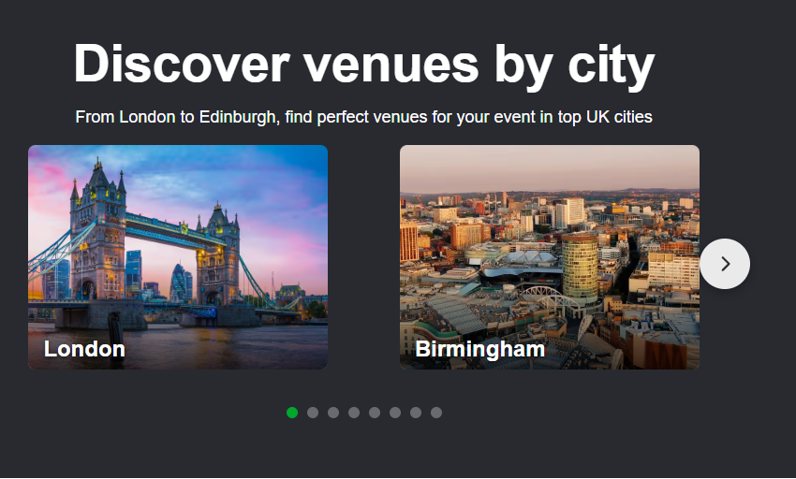
When you scroll down, the user can see that you can find a venue via city location. Which is useful if they live in or near a big city! It also means easier access because instead of having to filter through at the top, they can simply scroll down and find their location! This makes the website very easy to use for users.
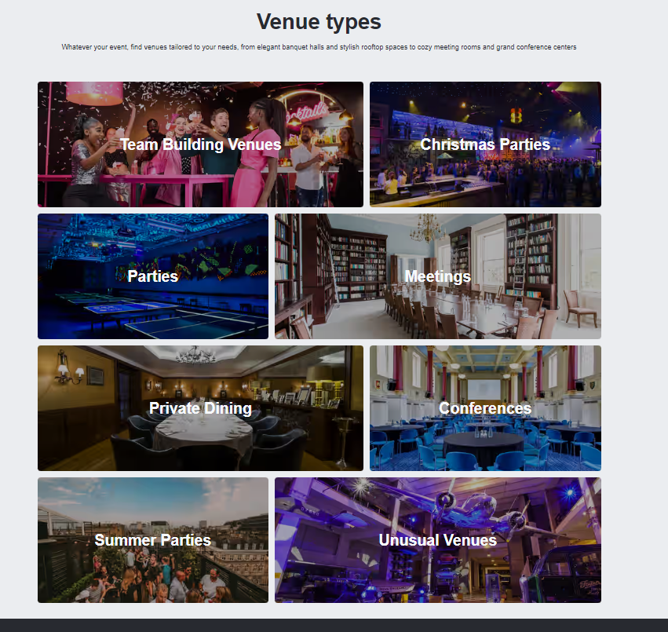

Upon scrolling further down, it appears you can filter through the different venue types! This makes it useful if a customer wants something specific, and can just look through all the different venues in that one specific category. They have a range of venues too, which appeals to a wider audience who doesn’t just want a venue for a party! Because of this, they’ll have more people wanting to book from them because they’ll have a venue specifically for them.
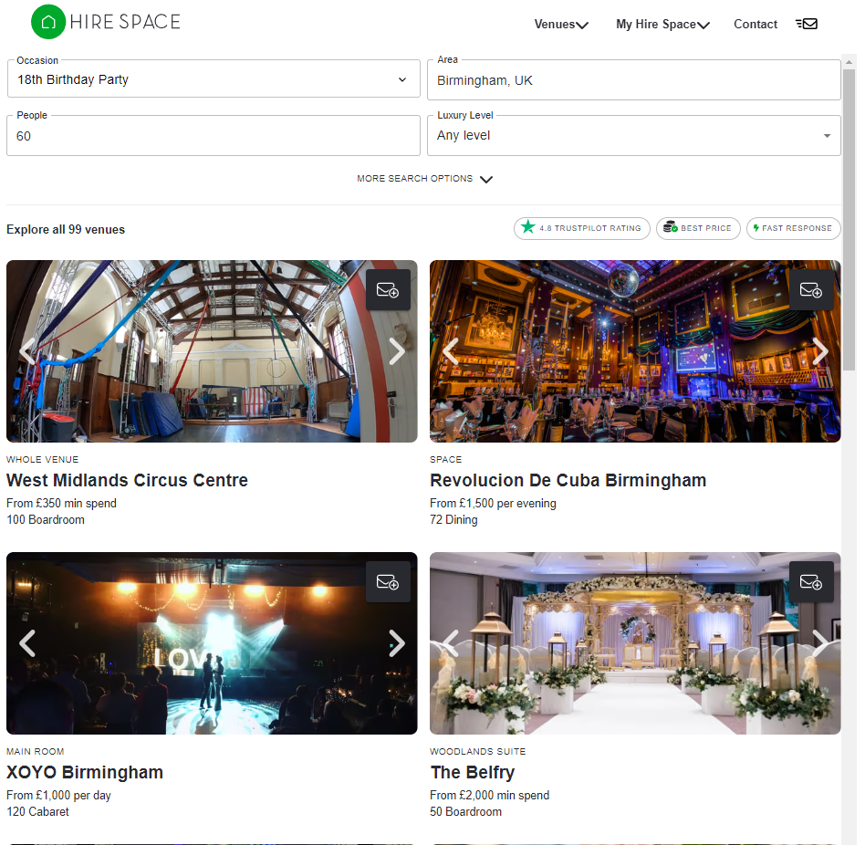

Upon filtering for a venue, it shows a range of exactly what you want, and it gives you an option to also filter by price, space, vibes, luxury, and to sort by price, relevance, and capacity.
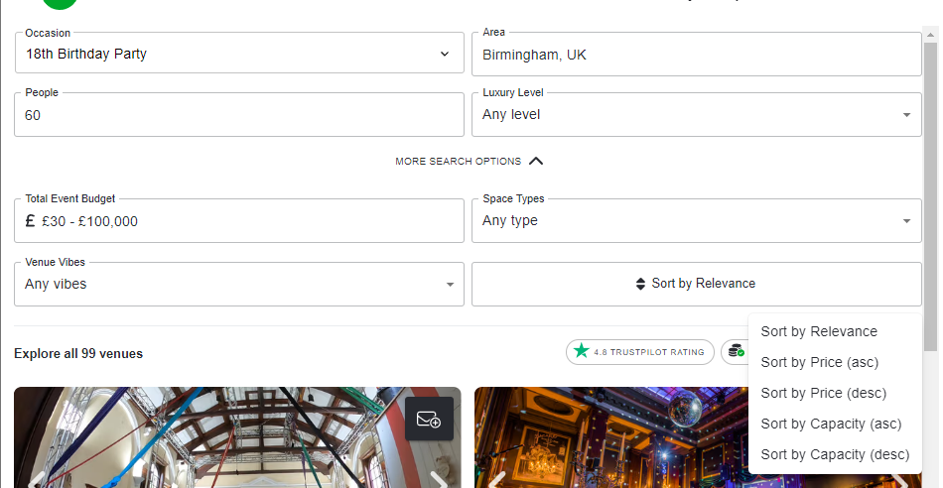

This means that anyone can find a venue that’s affordable for them, appealing to a wide audience. The navigation is very simple too, all you have to do is press a button and it filters everything for you, you can see the details too and contact the venue to be able to book. You can also make an enquiry list if you’re still not sure but want to keep it in mind while you look. Kind of like a shopping basket!

Example 2: Venue Crew
Link: https://www.venuecrew.com/
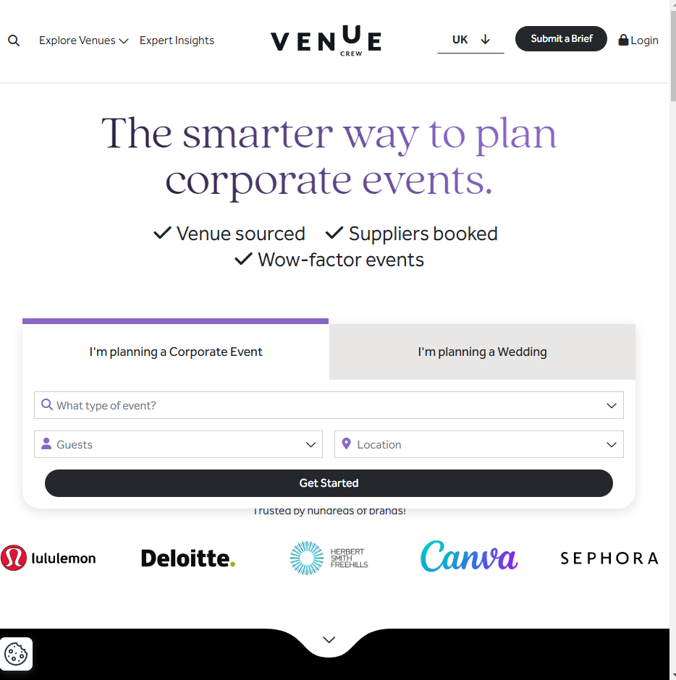
The first impression I get is that this website is catered towards corporate events. This means the website is catered to an older audience. The sleek minimalist look adds to the vibe of business and corporate too. The UI is simple too, which seems to be industry standard having it laid out like this. Because of the simplicity, it means anyone will be able to search and find a venue just for them.
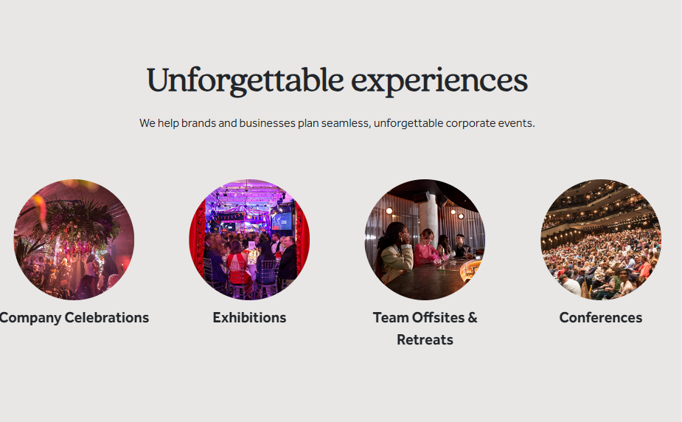
Upon scrolling down, the unforgettable experiences cycle through, showing all the different events you can book for the venue. The phrasing also makes people more included to book using this website because it promises the user a time they’ll never forget, and that’s what people want when booking venues.
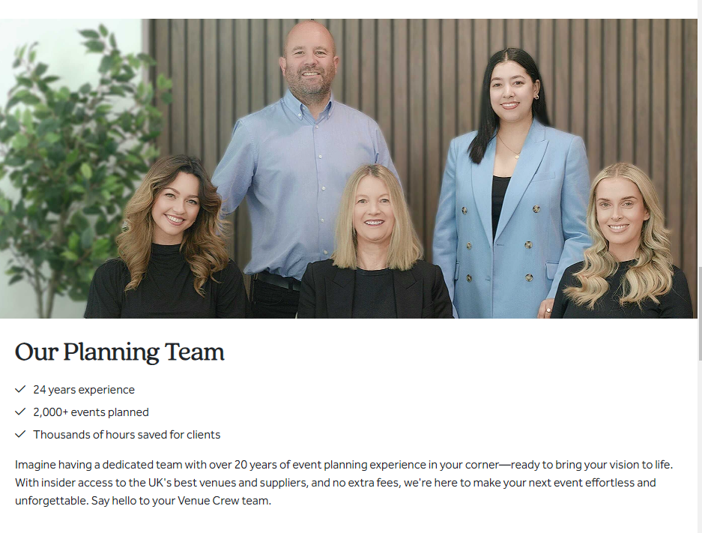

In this screenshot the user can see the credentials of the planning team, which builds trust in the user by using the statistics and the amount of experience they have, showing the user they will have an event go right!

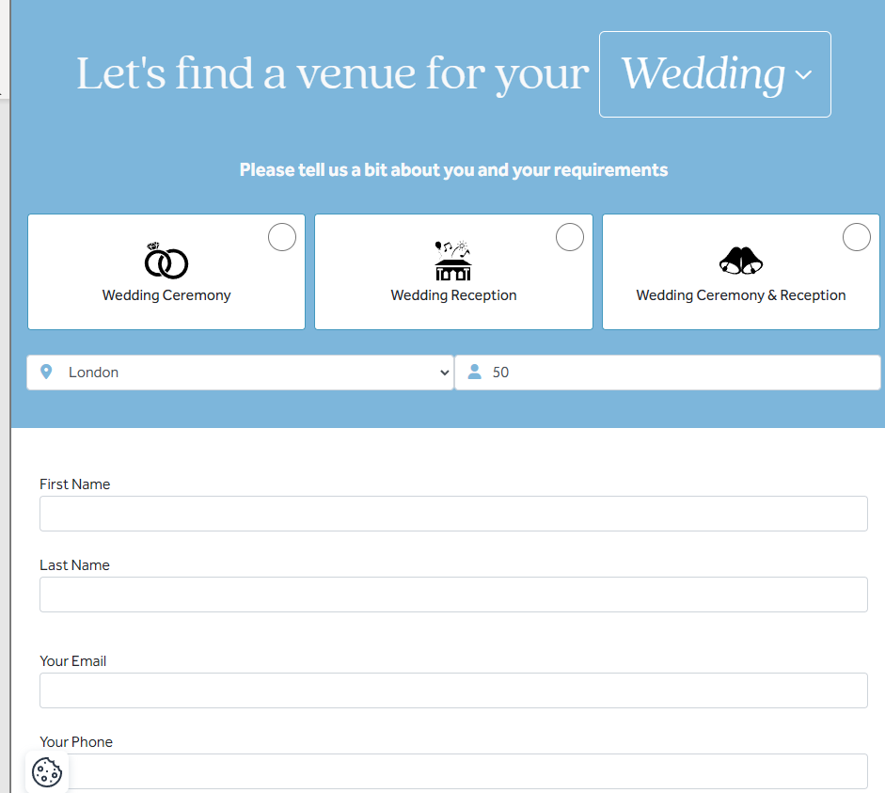
When you filter for a wedding, you get this form. Which shows that you won’t be finding the venue but the planning team will, and they will send you a lot of options so you know you found the right venue.

Business Context

Room hires for meetings, training sessions, and private events
The client has asked for an option to room hire for meetings, training sessions, and private events. This accommodates for a wide range of customer needs. The venue’s flexibility in catering towards different events is a key selling point that attracts businesses, community groups and individual people who need venues for a variety of things. Having a variety of room hires is also industry standard because having only a selection of one type of venue is very limited which decreases the audience that can use the website itself.

Equipment hires such as projectors, speakers, and seating
The client has also requested for equipment hires such as projectors, speakers, and seating. Having equipment alongside room hire means customers don’t need to source their own from either their own money or different providers. This streamlines the booking process and experience and increases profit due to customers being more likely to add equipment to their booking.

Short-term and day-long bookings
The client wants the platform to support both Short-term and day-long bookings for community groups and businesses. Offering flexible booking duration allows CityPoint to meet a wide range of user needs, which increases the number of clients CityPoint is able to reach out to. The flexibility also increases customer satisfaction which means users may tell friends or family looking to book a venue about CityPoint, which will increase profit and customer audience.

Provide customers info rooms available and their facilities
The client has asked for clear and accessible information about the rooms available for hire and their facilities. This allows customers to make informed decisions based on the room size, layout, included equipment, and if the rooms are available for the times the customer wants it. Providing this information online makes the use of staff enquiries minimal and helps the users feel confident when booking

Booking policies and staff details
The client has asked that booking policies and staff information for the company should be clearly displayed on the platform. This ensures the customers understand the terms and conditions before booking, such as: cancellations, payments, and usage rules. The booking policies being displayed clearly helps reduce customer misunderstandings and builds trust between the business and it’s audience. Staff details for the company is also important because it helps customers know who they’re working with building trust and more personalization between the staff and customer base which will increase loyalty to the business.

Booking specific dates and times pending confirmation
The client has requested a system that allows customers to request specific dates and times for bookings, while pending staff confirmation. This allows customers to submit booking request at any time, while also giving staff control over availability and scheduling. This also helps prevent double bookings for venues where two different people booked at the same place at the same time. It also ensures that bookings are managed more efficiently!

View and manage existing bookings
The client wants customers to be able to view and manage their existing bookings through the platform. This feature allows users to check booking details, make changes, or cancel if needed without contacting staff. Providing this self-service option improves user experience and reduces the workload for staff. It also means if something personal happens in a user’s life, they can change or cancel the booking easily without having to annoyingly contact different staff just to cancel, like some venue companies.

Account registration for customers
The client has requested an account registration function so customers can securely manage their bookings and personal information. This also means that their information will be saved so if they ever want to book again, they can easily. This encourages repeated business and company loyalty. And being able to access past bookings means they can always rebook if they really enjoyed the venue easily and recommend it to others.

Accessibility features
The client has asked for accessibility features to support a wide range of users. This ensures the website can be used by people with different needs and promotes inclusivity! Also, accessibility features are industry standard because it helps open up the customer base, and legally a website has to be accessible to people with disabilities.

Staff area to manage rooms and booking requests
The client has requested a dedicated staff area where employees can manage rooms and booking requests. This allows staff to confirm or deny bookings, update availability, and oversee daily operations from one central system. Having this feature improves efficiency and ensures bookings are handled accurately and promptly.

Project Aim
The aim of the project is to produce an online web application that has the following features:
- Room hires for meetings, training sessions, and private events
- Equipment hires such as projectors, speakers, and seating
- Short-term and day-long bookings for community groups and businesses
- Provide customers information about rooms available for hire and their facilities
- Provide information about booking policies and staff details for the company
- Allow customers to book specific dates and times pending confirmation
- Allow customers to view and manage their existing bookings
- Account registration to allow customers to manage their bookings and data
- Accessibility features to support a wide range of users
- A staff area to manage rooms and booking requests that they can confirm or deny

Functional Requirements
User story:
David just got promoted to manager and wants to book a company event at a venue. He is 36, and he’s not very technologically adept.

Lucy is a staff member at CityPoint Room Hire. She’s in charge of managing the bookings and availability

Sarah is an event planner organizing a large conference and needs to book multiple rooms for different sessions. She is experienced in event management but not very tech-savvy, so she needs a simple way to book all the rooms at once without confusion.

Functional Requirements | User Story | User Acceptance Criteria | Justification
Register | As David  I want to register an account  So that I can book a venue for my company event | - User can register using valid name, email, password  - Confirmation email or message is sent after successful registration  - Invalid or incomplete data shows an error message | Allows new users to create an account to access bookings, payments, and simplifies the process for the future
Log in | As David  I want to log in  So that I can access my bookings and event details | -Log in works with valid credentials  - Error message appears for incorrect input  - Successful login redirects to the dashboard | Ensures new users can securely access their account and review past and upcoming event details.
View available rooms | As David  I want to view available rooms for my company event  So that I can select the right one | -User logs in  -User inputs Venue button  -Redirects user to venues page  -User presses on a venue  -Shows them the venue information  -Can filter by room size, availability, and facilities  - Room details, including layout and capacity, are clearly displayed | Helps new users quickly find the right room for the right event, reducing decision-making time
Book a room | As David  I want to book a room for my company event  So that I can reserve it for the selected date | -User logs in  -User inputs Venue button  -Redirects user to venues page  -User presses on a venue  -Shows them the venue information  -Can filter by room size, availability, and facilities  - Room details, including layout and capacity, are clearly displayed  -Can select a date, time, and room  - A booking confirmation message appears  - Can review and modify the booking before finalizing it | Ensures new users can securely book a room for their event without any complications, even with limited technical knowledge
Manage Bookings | As David  I want to view and manage my event bookings  So that I can make changes if needed | -Can view upcoming events, rooms booked, and event details  - Can modify or cancel bookings through the interface | Provides new users with the flexibility to adjust event bookings in case of any changes
View booking policies | As David  I want to view the booking policies  So that I can understand the terms before confirming | -User logs in  -User inputs Policies button  -Redirects user to policies page  -Can access terms and conditions for booking, including cancellation policy, payment terms, and any restrictions  - Check box to click that says “I understand T&Cs” | Ensures new users fully understand the venues rules and avoids misunderstandings about event bookings
Confirm booking details | As Lucy  I want to confirm or deny booking requests for venues  So that I can manage the availability | -User logs in as a staff account  -User goes to pending booking confirmations page that has staff only access  -Redirects user to page  -Can view all pending booking requests  -Can confirm or deny bookings based on room availability and company policies  - Follows Data protection guidelines | Ensures staff can manage room bookings efficiently, preventing double bookings and ensuring a smooth operation
Room availability | As Lucy  I want to manage room availability  So that customers can only book available rooms | -User logs in as a staff account  -User goes to Venue availability page that has staff only access  -Look at availability  - confirm or deny them  - UI changes from available to unavailable if the booking is confirmed | Helps maintain accurate and up-to-date availability information, improving customer satisfaction and operational flow.
Staff access Management | As Lucy  I want to manage staff access to booking information  So that only authorized personnel can access it | -User logs in as a staff admin account  -User goes to management page that admins only have access to  -Can set permissions for other staff members to access or modify booking information  - Sensitive data is restricted to authorized staff | Ensures security and confidentiality of booking data, maintaining the integrity of the customer information
Booking history | As Sarah  I want to access my booking history  So that I can easily repeat successful bookings for future events | -User logs in  -User goes to bookings page  -Redirects user to bookings page  -User presses past bookings  -Redirects users to a page with a history of their past bookings  -Can view a list of previous bookings with details about rooms, dates, and services  - can rebook any previous events or rooms with a single click | Makes event planning faster and easier by allowing new users to repeat successful past events, enhancing efficiency in booking the same spaces or services.
Event Feedback and Rating | As Sarah  I want to rate my experience with the venue  So that my feedback helps improve venue services or lets other customers know what the venue is like | -User logs in  -User goes to bookings page  -Redirects user to bookings page  -User presses past bookings  -User sees their previous bookings and venues  -User can press on a venue and redirects them to the venue  -Underneath the venue there’s reviews  -Can rate the room, staff, and overall experience after the event using stars  - Feedback form is available after the event is completed | Provides valuable feedback to improve the venue’s services and helps future customers make informed decisions based on past experiences.
Multi-room booking | As Sarah  I want to book multiple rooms for different sessions at the same event  So that I can efficiently manage large-scale events | -User logs in  -User goes to venues page  -redirects user to the venues page  -user presses a venue they want to book  -Can select more than one room for booking at the same time  - Can choose different times for each room if necessary  - each room booking is confirmed separately | Allows users to quickly book all the rooms needed for her event, making it easier to organize large events without multiple individual bookings.
Event setup requests | As Lucy  I want to manage event setup requests (e.g., seating arrangements, AV equipment)  So that rooms are prepared according to client needs. | -User logs in as a staff account  -User goes to a bookings page that has staff only access  - user can view different bookings people have made  - Can view setup requests made by clients in the booking interface.  - Can confirm or deny requests based on room capacity and available resources. | Ensures that rooms are set up as requested by clients, improving customer satisfaction and reducing setup errors.

Non-Functional Requirements

Performance
Non-Functional Requirement | Justification | KPI
The website must load efficiently and consistently | A fast-loading site improves user experience and keeps visitors engaged. | Load within 15ms of opening  After 4 hours, still load within the 15ms
The website must maintain performance over time. | Ensures reliability even during long sessions. | After 4 hours of continuous use, still load pages within 1.5 seconds.
Security
Non-Functional Requirement | Justification | KPI
Log in data must be held securely in a database that users can’t access | Login data must be held securely in a database that users cannot access. | No unauthorized access attempts: sensitive data encrypted
All communication between the user and the server must be encrypted via HTTPS. | Ensures data privacy and protects sensitive information during transmission. | 100% of traffic over HTTPS; no insecure HTTP connections allowed.
User passwords must be hashed before storing in the database. | User passwords must be hashed before storing in the database. | Passwords must be stored using a secure hashing algorithm (e.g., bcrypt, Argon2).
Scalability
Non-Functional Requirement | Justification | KPI
The system must be able to handle an increasing number of users and data without slowing down. | Allows the application to grow as more users register or content increases. | Maintain response time under 2 seconds for up to 10 000 concurrent users.
The system must be able to scale horizontally to accommodate more users. | Supports business growth and increasing demand without compromising performance. | Horizontal scalability with automatic scaling to maintain response time below 2 seconds for 10,000 users.
The architecture must allow for the integration of new features as the business grows. | Ensures that new features can be added without requiring a full redesign of the system. | Average time for implementing new features should not exceed 2 weeks per feature.
Capacity
Non-Functional Requirement | Justification | KPI
The database must store large amounts of user, event, and booking data. | Supports long-term growth without needing frequent upgrades. | Store up to 1 million records with query time under 3 seconds.
The database must handle large media files (e.g., images, videos) related to event bookings. | Stores important visual content (e.g., event images) for easy access without performance issues. | Ability to store and retrieve 500,000 high-resolution images with load times under 5 seconds per image.
Reliability
Non-Functional Requirement | Justification | KPI
The website must be consistent and not crash during use. | Users need to be able to access events, view venue information, and manage bookings without interruptions. A reliable platform builds user trust and ensures smooth operation of all venues | System uptime of 99.9% per month.
The website must have a robust backup system for data recovery. | Ensures that user and business data are safely stored and recoverable in case of accidental loss. | Backup frequency: Daily; Recovery Time Objective (RTO) under 1 hour; Recovery Point Objective (RPO) under 30 minutes.
Usability
Non-Functional Requirement | Justification | KPI
The interface must be intuitive and easy to navigate. | Ensures users of all ages can use the website without training. | 90 % of test users complete main tasks without help.
The system must allow users to easily reset their passwords | Ensures users can regain access to their accounts in case they forget their passwords. | 95% of users successfully reset their passwords without needing additional support.
Accessibility
Non-Functional Requirement | Justification | KPI
The website must meet WCAG 2.1 AA accessibility standards. | Ensures inclusivity for users with visual or physical impairments. | Pass accessibility audit for WCAG 2.1 AA compliance.
The website must offer high-contrast modes for visually impaired users | Provides a clear visual interface for users with low vision. | High-contrast mode should be accessible with one-click toggle, and 100% of text should be legible in high contrast mode.

KPI – Key Performance indicator

Hierarchy Diagram
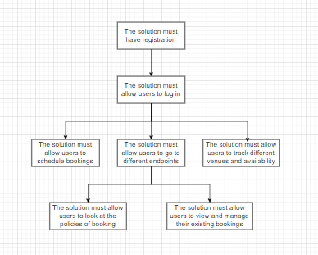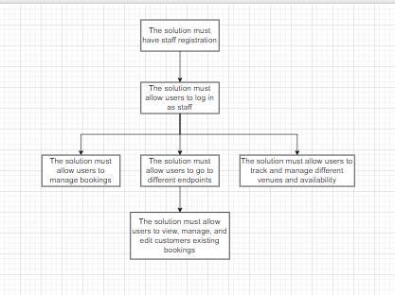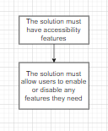

UI Considerations
Things I have considered implementing for the design phase includes the colour scheme, general aesthetic, spacing, and images.
The colour scheme should be simple. During my research I noticed brands tend to stick to 2 or 3 colours: white, an accent colour, and then a dark grey/black. This seems to be industry standard, with the only thing changing being the accent colour and whether the website itself is mostly white or mostly dark grey/black. Therefore, I will make the background black, with the accent colour being CityPoints brand’s colour scheme. The text colour should be white to allow contrast on the dark background. However, I will add an option for light mode for users who prefer it. The accent colour will stay the same, however the text and background colours will be swapped around.
The general aesthetic should be minimalistic and simple. With the 2 brands I have researched, there isn’t much going on. This is because the target audience is adults. Due to this, I will use the white space to create a modern and simple look for the website, which will make the key elements stand out. Because I want a modern look, I intend to use the Greycliff font because of its simplistic design that’s also easy to read. Greycliff is also from the sans serif font family, which means it’s more accessible to people with learning disabilities such as dyslexia.
Images is a given. Because CityPoint is a venue hiring website, users need to be able to see the venues to decide if it’s the one for them. Therefore, I will be sure to use copyright free images of the venues. This is also industry standard to include images of the venues for hire.

Security considerations and risk mitigation
Risk Description | Probability | Impact | Mitigation
(R1) System Failure | Moderate | High | Regular maintenance on website, and perform daily automated backups
(R2) Data Security Breach | Low | High | Encrypt the data, secure authentication, and follow data protection guidelines such as GDPR and DPA
(R3) SQL Injection | Low | High | Use ASP.NET core MVC that has built in SQL protection. And use prepared statements and parameterized queries
(R4) DDOS Attack | Low | High | Use Firewalls and rate limiting. Also use email verification system so fake emails can’t be used to register to bots
(R5) Brute Force to gain unauthorised access to a users account | Moderate | Significant | Implement 2 step verification system so a code will be sent to a users phone or email, and implement an account lockout after too many incorrect password attempts
(R6) Confusing Interface | Moderate | Significant | Do usability testing and make sure navigation is simple, clear, and easy to use
(R7) Double Bookings of Rooms | Moderate | High | Use a pending-confirmation booking system and require staff approval before confirming bookings
(R8) Delayed staff confirmation of Booking requests | High | Significant | Add staff dashboards and automated alerts for new booking requests

Risk Matrix
Impact
High | (R2) (R3) (R4) | (R1) (R7)
Significant |  | (R5) (R6) |  | (R8)
Moderate
Low
 | Low | Moderate | Significant | High
Probability

Legal and regulatory requirements
Venues attract a large variety of people; therefore, the platform must comply with the Web Content Accessibility Guidelines (WCAG) to ensure users with different disabilities can access and use the website normally and with ease. This includes features like text-to-speech, different colour modes, screen reader compatibility, keyboard navigation, and text resizing. This supports and helps users with different needs making the website easier to use and makes them have a better experience using the website.

The system will fully comply with the UK General Data Protection Regulation (UK GDPR) and the Data Protection Act 2018. This ensures all personal data is collected and processed securely, with user consent. Users must have the ability to view, edit, or delete their data, and all information will be stored in encrypted form; e.g., password hashing, encrypted data transfer (SSL/TLS).
Users also have to be informed clearly on how their data is being used, stored, and protected. And this will be done through a privacy policy which’ll explain user rights, data retention policies, and how users can manage their data.
In addition, to comply with privacy regulations, the platform will implement cookies which requires users to accept or deny them (cookies are small files placed on a user’s device by a web browser when visiting a website, designed to store data for tracking, authentication, and personalization). This ensures lawful collection and gains consent on collecting a user’s data which complies with GDPR and DPA.

Clear booking policies and terms and conditions will be displayed on the website. These documents will outline the rules on room and equipment hire, cancellations, payments, and user responsibilities. This helps prevent disputes and limits legal liability for CityPoint. And it also allows the company to enforce rules against misuse e.g., fraudulent bookings or damages. Also, a check in the booking system for when a user books a venue that serves alcohol or has entertainment that says, “This venue is licensed for alcohol and/or entertainment. All regulations under the Licensing Act 2003 apply. Customers must comply with venue rules.” This will protect CityPoint Legally and ensures users are aware of the licensing requirements.

CityPoint’s online booking system has to comply with the Consumer Rights Act 2015, which protects consumers when buying a service. This means that all services offered, like room hire, equipment hire, and booking management must be provided with reasonable care and skill, and be fit for purpose. Therefore the rooms and equipment have to match the online descriptions, and bookings have to meet the requirements specified by the customer.
The price of the venues also have to be clear and accurate information and if the venue isn’t as delivered or promised, they have a right to request a repeat performance, refund, or compensation. Compliancess with this act ensures customers are treated fairly, reduces disputes, and helps CityPoint maintain trust and credibility.

